Trail Life USA



Online Adventure Finder

Senior Project Proposal

Seth Bagdanov

Eric De La Cruz

Hugo Morales

June 2018

Fresno Pacific University

Computer Information Systems

Degree Completion Cohort 2018



**Table of Contents**

**Overview** **5**

**Organization Background** **6**

History 6

Services 6

Clients 6

Mission & Vision 7

MISSION 7

VISION 7

**Problem Statement** **8**

**Project Objectives** **9**

Main Objectives 9

Functional Requirements 9

**Definitions and Resources** **10**

**Project Team and Roles** **11**

**Proposal** **12**

Location 12

Proposed Solution 12

Existing System & Infrastructure 14

Hardware 15

Software 15

Updates 16

Security 16

Expected Benefits (Financial, Nonfinancial) 18

Costs 18

**Work Breakdown Structure** **20**

**Project Timeline** **22**

**Project Management** **23**

Integration 23

Scope 23

Roles and Responsibilities 23

Verification Techniques 24

Change Control 24

Scope Statements 25

Product Characteristics and Requirements 25

Project-Related Deliverables 25

Project Success Criteria 25

Time 25

Cost 26

Quality 26

Reliability 26

Efficiency 26

Security 27

Maintainability 27

Quality Control Checklist 27

Human Resources 29

Responsibility Assignment Matrix 29

Communications 30

Risk 30

Risk and Mitigation Matrix 31

Procurement 31

**Database** **33**

Entity Relationship Diagram 33

Data Dictionary 33

Data Flow Diagram 33

**Security** **34**

Network Diagram 34

Security Plan 34

Physical 34

Network 34

Application 34

File 35

Procedural 35

User 35

**Ethical Implications** **36**

**Functional Prototype** **37**

**Test Plan & Results** **38**

**Teamwork** **39**

**Communication** **40**

**Stakeholder Feedback** **41**

Email Feedback 41

Project Exit Questionnaire 43

Quality of Project 43

Scheduling 43

Responsiveness 43

Future Projects 43

Overall 44

**Lessons Learned** **45**

Opportunities For Improvement 45

Team Issues & Resolution 45

**Appendix A** **46**

Gantt Chart 46

**Appendix B** **49**

Entity Relationship Diagram 49

**Appendix C** **51**

Data Dictionary 51

**Appendix D** **67**

Data Flow Diagram 67

**Appendix E** **69**

Network Diagram 69

**Appendix F** **71**

Test Plan 71

[Online Adventure Finder  
Test Plan](#_wf45v41ut0q1) 72

INTRODUCTION 73

Purpose 73

Project Overview 73

Audience 73

TEST STRATEGY 74

Test Objective 74

Test Principles 74

Data Approach 74

User Acceptance Test (UAT) 74

Test Conditions 76

EXECUTION STRATEGY 79

Entry and Exit Criteria 79

Test Cycles 79

Validation and Defect Management 80

TEST MANAGEMENT PROCESS 81

Test Design Process 81

Test Execution Process 81

# Overview

This report outlines the details regarding the senior project of Seth Bagdanov, Eric De La Cruz, and Hugo Morales (the project team). The project result was an online event calendar system for Trail Life USA (TLUSA) and the organization’s members. The calendar system, named “Online Adventure Finder” or OAF, provides detailed information about scheduled events and activities, including locations, dates, and categories associated with the event. The project was completed at Fresno Pacific University during the Spring 2018 semester of the pilot Computer Information Systems Degree Completion program.

# 

# Organization Background

Trail Life USA (TLUSA) is a Christian outdoor adventure program that focuses on and teaches biblical moral values to more than 26,000 boys and young men in the United States. The program is intended to mold young leaders and focus on outdoor activities, build character, and develop leadership. Leaders are given the opportunity to enrich young minds and demonstrate Christian values. Members are organized into local troops that are chartered through a church.

## History

TLUSA was founded in June 2013 by a wide coalition of leaders in Louisville, Kentucky. It operates under the principle of shared leadership which seeks to involve those in the organization in a distributed management structure. Leaders are encouraged not to hog or exploit their authority and demonstrate the public nature of leadership.

## Services

Trail Life USA is a Christ-Centered program that emphasizes and teaches moral values. However, the program is designed and intended to be presented without being construed as “churchy” or “religious”. TLUSA is church-owned and operated which means that the charter organization is expected to own and operate the Troop by selecting its adult leaders. The services offered through TLUSA are outdoor-focused and enables the program to instill “Adventure, Character and Leadership” traits in young men. These activities consist of camping, hiking and other outdoor events. Safety is TLUSA’s main concern while youth participate in outdoor and indoor activities. Physical, emotional and spiritual health are integrated into everything offered by the program. There is flexibility so that the troops may adapt to the program to fit the needs of their unit. The main focus is to provide a family oriented experience.

## Clients

Clients and members of the program include adult males and biologically youth males under the age of 18 who meet membership criteria. Youth membership is available to all boys regardless of religion, race, national origin and socioeconomic status. Individuals must meet this membership criteria. Adult males over the age of 18 are required to abide by the program’s *Statement of Christian Faith and Values* as well as the program Oath and Motto. Membership is allowed to both adults and youth who refrain from engaging in or promoting sexual immorality, or those who engage in manners that become distractions to the program and its mission. TLUSA encourages young members whose parents look to pursue a faith-based outdoor activity program that instills character development, leadership, and moral purity.

## Mission & Vision

### MISSION

The mission of the project team is to help members of TLUSA locate local and national events by providing innovative and powerful technologies that are easily accessible, user friendly, and present information in a visually appealing way.

### VISION

The proposed solution will address TLUSA’s desire to augment and enhance their organization through the addition of a visual system. The system will enable the distribution of information quickly and easily to a nationwide audience.

# 

# Problem Statement

Currently, Trail Life does not have a system for managing all the events organized by the hundreds of troops nationwide. Trail Life does not have a central method of communication with participating troops regarding updates or changes to events. Payment for events is scattered across several different PayPal accounts and users must make payments and then contact the district to confirm the payment has been received and applied to the correct troop and activity.

# 

# Project Objectives

## Main Objectives

Our goal is to design, create and implement an event and activity tracking system in conjunction with the Northern California TLUSA district.

Our objective is to implement a calendaring system that allows all registered troops an opportunity to schedule and coordinate with others, empowering troops to expand their opportunity to interact with others in the community. Our team will design a web based application for troops to include their own events with hopes of teaming with other local or outside organizations. The objective of the system is to capture and process data and store this information in a database. Data to be collected will include relevant logistical details regarding the event, troop demographics, and payment information. The Event Tracker will be ready for handoff to TLUSA by June 30, 2018.

The Northern California district of Trail Life will have a functioning, easy-to-use system for scheduling and managing events. The event and activity schedule will be up to date and readily accessible through the internet. Members may browse, look up events on a calendar, and view the details for specific events.

The project will utilize a central database (MySQL) to store the collected information on a web server. A web user interface will be created to facilitate information display and collection. The database will be accessed and modified through Python and Django programming. The calendar system will also be implemented by Python.

An itemized list of project objectives are as follows:

* Maintain a centralized, organized record of events nationwide
* Effectively communicate a clear schedule to members and their families
* Implement the system by end of June 2018

## Functional Requirements

* Events page will record data provided by regional units that include location, date, event details, and cost
* Events will display in a calendar and list format
* A search function can be used to search events
* A filter tool can be used to tighten the search scope

# Definitions and Resources

Definitions

TLUSA - Travel Life USA

OAF - Online Adventure Finder, the title of the project solution

Resources

John Bagdanov  
*Primary Contact*  
Trail Life USA Northern California Pointman  
[jbagman7@gmail.com](mailto:jbagman7@gmail.com)

# 

# Project Team and Roles

The project team will consist of Seth Bagdanov, Eric De La Cruz, and Hugo Morales. Roles will be assigned as follows.

**Seth Bagdanov** - Project Manager, Lead Programmer  
Seth will be the team leader for the project and coordinate communication and progress between team members to ensure timelines are met. Seth will be the programming lead for writing and debugging code. He will assign programming tasks to team members when appropriate.

**Eric De La Cruz** - Proposal Team, Database Lead  
Eric will work on project documentation and assist Hugo to plan and complete the report documents. Eric will also be the database lead and design and create the database structure to be used by the project.

**Hugo Morales** - Proposal Team, Primary Liaison Officer, Lead UI Designer  
Hugo will work on the project proposal and assist Eric to plan and complete the documentation. Hugo will be the liaison between the team and the client to facilitate accurate and timely communication. Hugo will also be the UI designer lead and work with the client to design an efficient and effective user interface to be implemented in the project.

# 

# Proposal

## Location

The project will be implemented on a cloud-based solution so geographical location is irrelevant. Events submitted to the system will be located across the United States. The project team is located in Fresno, CA.

## Proposed Solution

The proposed solution will build a central calendaring system that allows troops to create and edit events and will also allow troop members to view local events available to them. The solution will be web-based and accessible through any web browser. System administration will also be performed through a web interface with appropriate security precautions.

The proposed system will have three primary functions:

1. Secure data access and implement user profile management
2. Collect and store local event data
3. Present event data to users in a logical and functional manner

Access to the system will be managed. There will be no “Guest” or public access to the portal. Users will be able to register for their own account with a working email for verification. Admin users of various levels will have the permissions to edit events based on their group membership. Levels of admin permissions are distributed as follows:

| Site Admin - global control of entire system |  |  |  |
| --- | --- | --- | --- |
| > | Regional Admin - access to any regional and lower events |  |  |
| > | > | Troop Admin - permission to create and edit events for member troop only |  |
| > | > | > | Users - Read-only access to events |

Site administrators will have complete control of the system. They may change any event. They have the ability to change settings in the program and make preset modifications to the database.

Regional administrators have control over any event in their district. They may make changes to the events only and have no control over the main system or database.

The troop administrator has the ability to approve or create events. They may create events and only modify events they have created.

The system will collect event data provided by the users and save it to a persistent SQL database. Each data set will be saved as an event record and stored in the database. The data will be inputted into a webpage form and submitted by the user. The webpage will send it to a Python routine for validation and writing to the database. Data collected on the “Create Event” page will be as follows:

1. Event title
2. Event dates
3. Event start/stop times
4. Event contact name
5. Event contact details
6. Payment URL
7. Event location address
8. Event location Google Maps URL
9. Event category

Events will be tagged by category for quick reference and filtering. Categories will be predefined but able to be modified by site admins. Initial categories will be created as specified below:

* Campout
* Backpacking Trip
* Service Project
* Training
* Community Event (Parade, etc)
* Regional Events
* National Events

The system will present data to the users in a calendar format on a webpage. Users will be able to view upcoming events and the relevant information regarding them. Filtering options will be available to restrict viewing to certain geographical locations or by event type. The display format will be intuitive and easy to use for any user.

Regarding financial payment options to register for events: There are currently no methods of payment in place. Each individual who submits an event will be in charge of providing their own payment link. We do not plan on incorporating credit card processing into the system but will develop with this future add-on in mind. It will likely be implemented via a third-party plugin provided by the card processing provider when contracted.

## Existing System & Infrastructure

TLUSA corporate office is currently partnered with TroopTrack to manage events and advancement tracking but this is being discontinued in the immediate future due to licensing changes by TroopTrack. The current system relies on contact via email or telephone to create events and has no way to share a master list of events. There is no current system with the functionality to collect and organize events in one central place.

There is an existing Hostmonster account with web hosting that could be leveraged to provide a platform for the solution. It would offer cloud hosting for the website and database. Final solution will include installation and configuration of the new system and documentation required for training of administrators.

## 

## Hardware

TLUSA does not own any physical hardware and uses the cloud hosting by Hostmonster. HostMonster uses Linux based servers: most notably Apache NGINX servers on CentOS. The vendor provides the hardware and interface to the system, manages security and updates, and offers tech support when necessary. Hostmonster also mentioned that they could not disclose specific hardware to the public, due to strict company policy. By using a cloud provider, the acquisition and management of physical hardware is not required.

## Software

Currently Trail Life is using HostMonster as a web hosting service. HostMonster is offering the best prices for what we need currently. Using HostMonster allows Trail Life USA to upgrade hosting performance between VPS hosting and dedicated hosting. Other hosting sites considered were Godaddy, HostGator, and TMD hosting. The alternatives offer similar hosting packages with competitive prices. Due to the fact that TLUSA already has an established account with HostMonster, we recommend maintaining a relationship with this vendor.

TLUSA also uses Podio for mobile optimization of their website. Trail LIfe is also registered with TroopTrack to track troops and its members. The corporate office uses Configio for event management and scheduling but does not give local troops or districts access to this system. TLUSA currently has no plans to renew deal with Configio due to lack of user access, creating, or updating troop activities at the district level.

The proposed solution will be presented to the user as a web application available through any internet-connected device. The solution will use a combination of software resources to create its functionality. Web hosting will serve the final project to the users. A database will store and organize user data. Python scripting will manage access to the database and control read/write requests. HTML and CSS will present a front end to the end user.

Web hosting and access will be provided by Hostmonster. The vendor will provide the backend hosting software which will remain transparent to the project team and the interface to be used. Hosting will either use a Windows IIS Server or Linux server solution but the interface used by the project team will be the same. The front end of the solution will be presented to the user via HTML pages served by the vendor server.

The hosting vendor will provide a server running the latest version of Python. Files will be uploaded to the server and executed using the install of Python and Django.

The SQL server will also be installed on the vendor hosting server. Data will be collected through web page forms. It will be validated and written to the database via Django. A blank database will be designed and created on the server for use.

## Updates

Fresno Pacific cohort team will satisfy update requests to the extent of meeting the original agreement including bug fixes and syntax errors that cause the system to not function as agreed. Updates to improve or change the entire system will be based on degree of change and price will be included with respect to the scope of the change request.

## Security

There will be three aspects of security considered in this project:

* Server security
* Database security
* User security

Server security will be managed by the hosting provider. The vendor will provide server resource allocation in a physically secured datacenter. Operating system and software security patches will be managed and installed automatically by the vendor. No customer interaction will be necessary to maintain the security of the server itself.

A SSL certificate will be purchased and configured for the site. SSL/TLS protocols will secure the traffic to and from the website to ensure the confidentiality and integrity of the data. The client will need to renew and install the new certificate prior to the expiration date. They will be responsible for this maintenance and can easily be performed in under half an hour. Standard SSL certificate durations are one or two years. We recommend purchasing the two-year certificate because it is the best value for the price and it doubles the length of time required before needing to renew and rekey the server. Selecting two years over one essentially halfs the labor required to maintain SSL security on the site.

The organization will be responsible to implement a backup strategy to solution. Backups provide the necessary security if the organization loses their data. A secure backup provides a trusted repository for the latest copies of the system and data that can be used to restore a known clean system to production. TLUSA will have different options to backup their calendaring system, including backing up the system to physical storage or to a cloud-based solution. Some web hosting companies provide an automated backup service and have a backup schedule and restore policies. The organization will need to contact the hosting company to find out more information if this service is available. The project team recommends maintaining both physical and cloud backups of the data. An optimal schedule would include nightly backups to a cloud backup with weekly, monthly, and quarterly physical backups stored on physical storage media. The backup media should be offline when not in use and physically secured to prevent against theft.

Private information in the database will be encrypted on a per-field basis. Only specific fields will be encrypted as needed to optimize both performance and security. The sensitivity of the field will determine whether or not it is encrypted. Information that could cause harm beyond that of an inconvenience will be encrypted in the database. The Django framework will handle database field encryption and decryption procedures. The storage and presentation of encrypted data fields will be completely transparent to the end user.

User access to the system will be limited to further secure the confidentiality of the data. Users will have individual accounts as previously discussed in the “Proposal: Proposed Solution” section. Guest access will not be permitted. There will be four permission levels available for users to receive: User, Troop Admin, District Admin, Site Admin. These permissions are summarized in the table below:

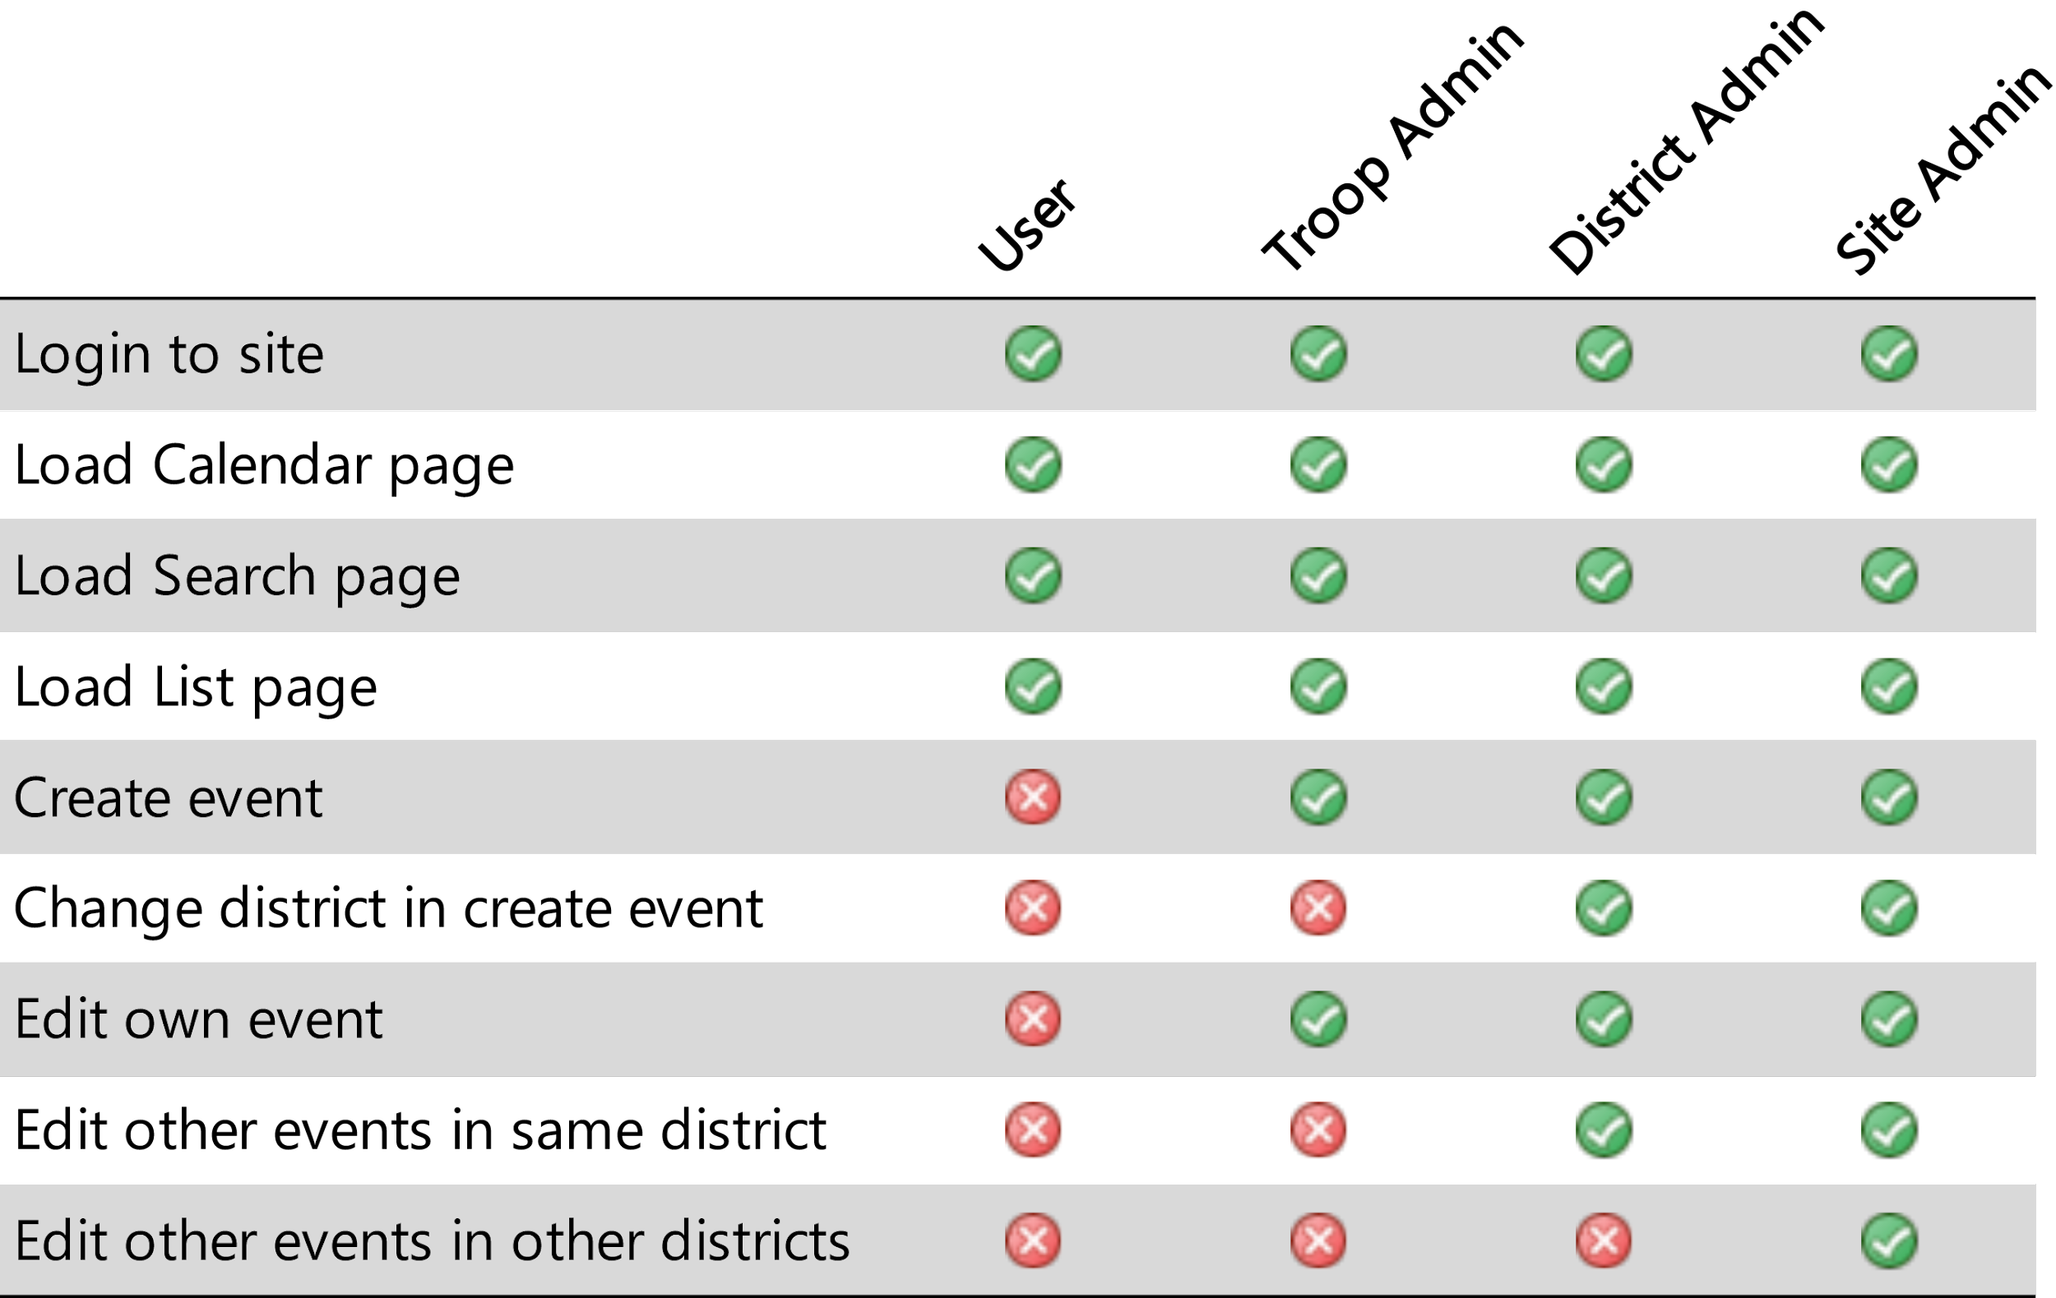

Standard users may signup using the public webpage and will receive only read access to the site and will be denied access to any “create” or “edit” functionality.

Troop Admin users will receive all previous permissions plus the ability to create events hard coded to their parent troop and district. The create form uses Python methods to load the user’s district so it is not possible to craft a malicious create POST request to override the event’s district. This user level may edit only events which they created.

District Admins receive all previous permissions plus the ability to edit any event but only in their district. They are not restricted by event owner. They may promote or demote users to the Troop Admin level. The district lock is handled by Python methods as above to provide this restriction completely isolated from the user environment.

Site Admins receive all previous permissions plus the ability to create and/or edit any event in any district. They may promote or demote users to Troop Admin or District Admin levels.

For purposes of this project, the superuser account is not considered to be a production account and should not be used in the course of daily functions on the site.

All permissions are checked via Python getter methods which check the user or event attributes. They are called by accessing a model instance. An example of the User get_troop() method is below:

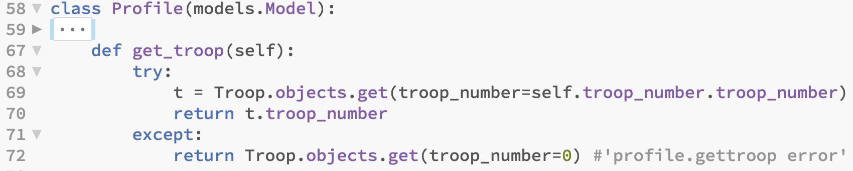

## Expected Benefits (Financial, Nonfinancial)

The addition of a calendaring system to TLUSA's organization will provide a centralized resource for registered users to access and promote their own activities to other troops. This will enhance communications with other troops as the events posted in the calendar will have detailed information about the event and who is organizing the event. This system may not directly entice new members to join the organization but it will help support troops that are already registered.

Because of the centralized nature of the material, it will be easier for members to locate events nearby. Activity participation will increase which gives members more opportunities to interact with other members. There is the chance to learn additional skills from the expanded member base. Finally, the increase in attendance will boost the impact events have on the community. Service projects, for example, will be able to accomplish more with greater manpower.

Improving the organization’s web presence to include the calendaring system betters the end user’s experience for both the member and activity leadership. With the end users able to view more information about events, it relieves the burden on the staff from the additional contact requests for event details.

## Costs

The financial costs for the calendaring system project will be minimal. There is already a hosting account purchased that is being donated for the implementation of this project. Beyond this, should they choose to move hosting to another provider, the cost would be about $50/year for the basic package or $100/year for an upgraded performance package, should traffic grow so large as to require additional bandwidth. For the near future, the basic package should be fine. Until multiple states begin using the system, traffic should be minimal and suitable for the basic package. An SSL certificate to secure the website traffic will run an additional ~$70/year.

Administrators of this application will need a one time training to understand the application. The cost of training is not determined. The training will go into depth and will show administrators how to manage and operate the functions within the calendaring system. Employee training is the responsibility of the organization’s leadership. Employee development is a shared responsibility of management and the individual employee. Admin roles will be distributed amongst the TLUSA volunteer regional leads and they will take control of account maintenance tasks at no cost.

There will be no development cost of the calendaring system application project. The maintenance of the system will be minimal with the hosting vendor providing the hardware and software updates as part of the hosting price. Technical support costs for the application itself will not be included and should be negligible. Ongoing technical support and software development will be offered by the project manager on a volunteer basis as schedule allows.

The collection of financial expenses are as follows:

| **Duration** | **Service** | **Price** |
| --- | --- | --- |
| 1 Year | Web Hosting | $50 - $100 |
| 1 Year | Domain | $12 |
| 1 Year | SSL Certificate | $70 |
|  | System Updates | *Not provided* |
| **1 Year** | **Total** | $132 - $182 |

# 

# Work Breakdown Structure

1. Phase 1: Planning
   1. Select project manager
   2. Define project teams
      1. Identify team members
      2. Assign roles
   3. Write project proposal
      1. Overview
      2. Organization Background
      3. Problem Statement
      4. Project Objectives
      5. Definitions and Resources
      6. Project Team and Roles
      7. Proposal
         1. Location
         2. Proposed Solution
         3. Existing System and Infrastructure
         4. Hardware
         5. Software
         6. Updates
         7. Security
         8. Expected Benefits
         9. Costs
      8. Work Breakdown Structure
      9. Project Timeline
   4. Write project presentation
2. Phase 2: Database Design
   1. Identify essential data
   2. Define database structure
      1. Define Tables
      2. Define Keys
      3. Define Relationships
3. Phase 3: Software Design
   1. Identify site structure
   2. Build Django project
      1. Install libraries and dependencies
      2. Code models
      3. Code views
      4. Code forms
      5. Code URLs
4. Phase 4: UI Design
   1. Site layout wireframe mockup
   2. Write HTML pages
   3. Write CSS
5. Phase 5: Testing
   1. Test functionality
      1. User permissions
      2. Event modification
      3. Event filtering
6. Phase 6: Implementation
   1. Install domain on server
   2. Install Django on server
   3. Configure Django
   4. Migrate Django project to web server

# 

# Project Timeline

The project timeline Gantt chart is located in **Appendix A** of this report.

# 

# Project Management

## Integration

This project embodies all aspects of Project Integration Management. Initiating development of the project unified all team members and focused on following the client’s original specifications and created the project deliverables under the four constraints of scope, time, cost, and quality. The project team implemented project knowledge areas through each phase of the project life cycle. Any and all change requests will be brought to the attention of the project manager. This process ensures all team members are in line with project objectives.

## Scope

The Scope Management Plan is to ensure the project is complete with the amount of work performed. The following sections will introduce how the project will come together and how it is designed, observed and controlled. This plan defines the roles and responsibilities as well as processes and procedures for managing the project and controlling the project scope.

### Roles and Responsibilities

| **Name** | **Role** | **Responsibility** |
| --- | --- | --- |
| Trail Life USA | Project Sponsor | Approves Scope Management Plan  Reviews escalated scope issues and provides direction for resolution  Approves major scope change requests |
| Seth Bagdanov | Project Manager | Overall responsibility for scope management  Oversees the development of the Scope Management Plan  Oversees the change management process  Ensures that scope changes are incorporated into appropriate project documents |
| Hugo Morales  Eric De La Cruz | Project Team Members | Helps develop the project scope statement  Submits scope change requests  Reviews change requests when assigned  Provides feedback as required  Participates in team-level scope change reviews |

### Verification Techniques

**Inspection:** A visual examination of the application will be done in order to test and make sure that all of the application screens requested by the stakeholder are in the web application. Check that fields needed for data entry, verify that the necessary buttons exist for initiating required functionality, etc.

**Demonstration:** Create a normal user account and an admin user to be able to enter all the required information and post an event in the application. Ensure that the events post in the right date according to the date of the event. Demonstrate the ability to add and remove events from specific users using the admin user account.

**Test:** Login using an account and create a new event. Fill out the form with the necessary information for the event that will be posted. Check the validation of the form to return an errors if one of the fields needs specific formatting or rules. Ensure that the user can post and review the event they created. Test that all the users can see each others event posts and view them.

**Analysis:** TLUSA will implement this application on their website to be able to receive feedback. Will measure the response time of the application posts. Have several users login to the system and have them create events to test the response of the calendar. Check that the calendar will not overwrite any existing events. Complete a series of tests in which specified number of users input an event into one specific date to see inspect the behavior of the calendar when that specific day gets to many inputs. See the comprehensive Test Plan for further information.

### Change Control

For the initial project, no formal change control protocols will be implemented. The project scale does not require a detailed level of tracking and integrating changes. Any change requests from the stakeholder will be addressed to the project liaison. Changes will be discussed among the team via group messaging. The best method of integrating into the project will be agreed upon and assigned to the respective team member.

### Scope Statements

#### Product Characteristics and Requirements

The requirements of the project are as follows:

* Secure data access and implement user profile management
* Collect and store local event data
* Present event data to users in a logical and functional manner
* Implement the system by end of June 2018

The project must be accessible online and be optimized for both desktop and mobile devices. It must communicate a schedule to members and their families. The events must be centrally stored and organized. The calendar must filter and display events based on certain criteria specified by the user.

#### Project-Related Deliverables

* Final Project Presentation
* Website documentation
* Live website
* Website files ZIP

### Project Success Criteria

1. Website is live and accessible online by the proposed date
2. Users must authenticate to site before viewing events
3. Calendar displays requested events to the user
4. Event details are easy to understand when viewing

## Time

In Phase One, the programming team focused on understanding the issues involved in developing a web application, while also including organizational mission and strategies, organizational structure, project management processes, and data availability.

After developing and putting a plan and schedule in place, subsequent steps in Phase Two and following continued to build on the team’s understanding and knowledge in programming and base knowledge in putting together a calendaring system.

The project’s Gantt chart is included under **Appendix A**.

## 

## Cost

The stakeholder maintains an ongoing contract with Hostmonster for web hosting services. Our product will integrate with those existing services. TLUSA is the authoritative entity; if services need to be switched, a new hosting site will cost between $50 - $100 depending on the type of package required. The OAF application will require no initial funds to be implemented. Any time accrued is donated to Trail Life USA. All updates or changes to cost will run through the TLUSA contact (John) for approval. Cost reporting will be reported weekly by the project team and monthly to the stakeholder. These frequency of these reports may be altered if unforeseen changes occur. The project manager is responsible for change control within the original requirements. TLUSA is the overall authority to major changes or changes to original requirements that require additional funding.

As a non-profit organization the goal is not to create a surplus of revenue but to create a centralized website that allows clubs and organizations an access point to communicate and distribute information. The annual cost to run and maintain the website is $132 - $182 per year. Trail Life USA has multiple options that can create avenues for revenue, such as utilizing payment options (PayPal, Square Cash or direct payment) to include a small percentage to go towards TLUSA and its continuing growth.

## Quality

Quality management ensures that the completed project not simply fulfills the requirements but also meets client expectations. Quality controls are performed throughout the project to maintain standards. Metrics are established to ensure the stakeholder and project team understand what is required. The metrics for this project are listed below.

#### Reliability

1. All software patterns are tested for unexpected behaviors such as uninitialized variables or unhandled exceptions
2. Methods, procedures, and functions performing data queries include error handling

#### Efficiency

1. Centralization of client requests to reduce network traffic
2. SQL database will avoid SQL queries that require multiple hits to process or that involve unnecessarily large sets of records

#### Security

1. Avoid data access without including error management. False requests will be taken care of with appropriate error handling
2. Input validation and sanitization to avoid cross-site scripting or SQL injections attacks

#### Maintainability

1. Database deep inheritance trees and nesting should be avoided
2. Follow best practice naming conventions
3. Use commenting appropriately throughout all source code files

### Quality Control Checklist

| **Project: Online Adventure Finder** | | | | **Date: 5/18/2018** |
| --- | --- | --- | --- | --- |
| **Quality Item** | **Verification** | | | |
|  | **Yes** | **No** | **Date** | **Comments** |
| Does the project have an approved quality management plan? | Yes |  | 5/18/18 |  |
| Has the quality management plan been reviewed by all stakeholders? | Yes |  | 1/18/18 | Approved and started the project |
| Do all stakeholders have access to the quality management plan? | Yes |  | 5/18/18 | Files are shared in Google Drive and accessible by all stakeholders |
| Is the quality management plan consistent with the rest of the overall project plan? | Yes |  | 5/18/18 | The quality management plan is reviewed on a weekly basis by PM |
| Have product quality metrics been established, reviewed, and agreed upon? | Yes |  | 5/18/18 | The quality metrics have been created and reviewed |
| Do all metrics support a quality standard which is acceptable to the client? | Yes |  | 5/18/18 | Client is satisfied with current production |
| Have quality metrics review meetings been scheduled throughout the project's duration? | Yes |  | 6/28/2018 | Project team has bi-weekly meets with SME during course of design |
| Are all metrics clear, measurable, controllable, and reportable? | Yes |  | 5/18/18 | All metrics are requirements for the project |
| Has the project team established a repository for all quality documentation? | Yes |  | 5/18/18 | Google drive is being used for documentation and a GitHub repository for the source code |
| Have all appropriate team members been notified of their required participation in quality reviews? | Yes |  | 5/18/18 | Development teams holds meetings for quality reviews |
| Has a project quality manager been assigned? | Yes |  | 5/18/18 | Manager has been assigned |
| Is the project sponsor aware of his/her responsibilities relating to quality acceptance? | Yes |  |  | Changes are approved by manager |
| Is the client aware of his/her responsibilities relating to quality acceptance? |  |  | 6/28/2018 | Client is updated on current process but holds no responsibilities in project development |

## Human Resources

The Human Resources Plan includes a general description of how the project manager and project team can use the plan to help them manage the project effectively. This helps achieve project success by ensuring that all tasks get completed and provide necessary help or training if needed.

The roles and responsibilities for the project are essential to project success. All team members must clearly understand their roles and responsibilities in order to successfully perform their portion of the project.

**Project Manager (PM)**: Responsible for the success of the project. The PM must approve all project changes and needs to report the project status in accordance with the communications management plan.

**Application Design (AD)**: Responsible for gathering requirements and building the application. The ADs are responsible for all design and testing of the application. The ADs will assist with the implementation of the Django and Python frameworks. The ADs will also be responsible for timely status reporting to the PM as required by the communications management plan. The ADs must be knowledgeable in Python and Django with HTML/CSS proficiency.

For the OAF Application, the project staff will consist entirely of internal resources in the Fresno Pacific University Degree Completion cohort members. The project team will work on the project from home. All work will be done from their personal devices and kept in sync with GitHub.There will be no outsourcing/contracting performed within the scope of this project.

There is currently no training scheduled and the development team will be responsible to ask for help. The Internet will be used as a resource for learning and troubleshooting.

The project manager will review each team member’s assigned work activities and make any necessary changes.

Although the scope of this project does not allow for ample time to provide cross-training or potential for monetary rewards, a party will be held to celebrate the success of completing the project.

### Responsibility Assignment Matrix

The following responsibility assignment matrix (RAM) assigns each item of the work breakdown structure (WBS) to members of the project team. Project team members are shown along the left-hand column. The top header reflects the sections of the WBS (see Section “Work Breakdown Structure” for complete document).

*A “P” indicates the performing member.*

*A “R” indicates the responsible member.*

*A “R P” indicates the member is both responsible for managing the task and will be performing work on the line item.*

|  | 1.1 | 1.2.1 | 1.2.2 | 1.3 | 1.4 | 2.1 | 2.2 | 3.1 | 3.2 | 4.1 | 4.2 | 4.3 | 5.1.1 | 5.1.2 | 5.1.3 | 6.1 | 6.2 | 6.2 | 6.3 | 6.4 | 6.5 |
| --- | --- | --- | --- | --- | --- | --- | --- | --- | --- | --- | --- | --- | --- | --- | --- | --- | --- | --- | --- | --- | --- |
| Eric De La Cruz |  |  |  | P | P | R P | R P |  |  |  | P | P | R P | R P | R P |  |  |  |  |  |  |
| Hugo Morales |  |  |  | P | P | P |  | R P |  | R P | R P | R P | P | P | P | P | P | P | P | P | P |
| Seth Bagdanov | R P | R P | R P | R P | R P |  |  |  | R P |  |  | P |  |  |  | R P | R P | R P | R P | R P | R P |

## Communications

| **Stakeholder** | **Communications Method** | **Frequency** | **Responsibility** | **Notes** |
| --- | --- | --- | --- | --- |
| Key Stakeholder | Email | Throughout project | Liaison Officer | Liaison Officer will maintain communication with stakeholder |
| Development Team | Stand-up Meetings Screen Sharing  Group Chat | Weekly-  Tuesday 10pm;  Chat as needed | Project manager & developers | Review project status, schedule, change requests, outstanding issues |

## Risk

Each project team member will be responsible of managing their risk project tasks. Risk identification will involve the project team, appropriate stakeholder. Careful attention will be given to the project deliverables, assumptions and constraints, WBS, and other key project documents. All project change requests will be analyzed for their possible impact to the project risks.

### 

### Risk and Mitigation Matrix

| **Risk** | **Chance** | **Risk Type** | **Owner** | **Contingencies / Mitigation Approach** |
| --- | --- | --- | --- | --- |
| Modules will not be completed on schedule | 50% | Personnel | SB | Resources will be reassigned to work on late modules and/or the schedule adjusted to accommodate the new timeline |
| Source code repository data corruption or overwrite | 20% | Third Party | SB | Team will be trained on GitHub to prevent accidental pushes. GitHub maintains a version history to restore a previous good version. Visual Studio safeguards against data loss by forcing a local copy before push/pull to GitHub. |
| Team turnover | 5% | Personnel | SB | Team duties will be redistributed. Project scope may have to be adjusted. |
| Third party services are unavailable | 10% | Third Party | SB | Code will be shared via emailed ZIP file. Local copies of shared files are saved to PMs computer and may be accessed offline. |
| Hardware crash | 10% | Hardware | Any | Two team members have backup devices to continue work on. The third may borrow a backup computer if required. |

## Procurement

The required outside services to produce and host OAF include four main components:

* Microsoft Visual Studio
* Python + Django
* GitHub
* HostMonster

Microsoft Visual Studio will be downloaded by each member of the project team through Microsoft Imagine at no cost for students attending Fresno Pacific University. Django is an open-source framework that is written in Python and can be downloaded at no cost. GitHub is an open source cloud-based code management solution that each project team member will utilize to sync/share source code in connection with Visual Studio. HostMonster will be furnished by the host vendor (TLUSA) to host the website via the internet.

Each team member is responsible for providing their own computers to work on the project. They will also be responsible for downloading, installing, and configuring the local copy of Visual Studio, Django, and Python on their personal devices.

The project manager will setup the GitHub repo and share it with the other team members.

Any other hardware, software, or account procurement will be assigned by the project manager to an available team member.

| **Procurement Plan** | | | | | | | |
| --- | --- | --- | --- | --- | --- | --- | --- |
| **Project:**  Online Adventure  Finder | | **PCN:**  01 | | **Project Manager:**  Seth Bagdanov | | **Engineers:**  Eric De la Cruz  Hugo Morales | |
| **Type of Service** | **Date**  **Needed** | **Type of**  **Contract** | **Lead**  **Time** | **Contract**  **Manager** | **Estimated**  **Cost** | **Contract End**  **Date** | **Total**  **Contract**  **Value** |
| Microsoft  Visual Studio | 01/16/2018 | Purchase | 6 months | Microsoft | $0 | n.d. | $0 |
| Python +  Django | 01/16/2018 | Open  source | 6  months | Python | $0 | n.d. | $0 |
| GitHub | 01/16/2018 | Open  source | 6 months | GitHub | $0 | n.d. | $0 |
| HostMonster | 6/26/2018 | Annual | 2 weeks | TLUSA | $0 | n.d. | $0 |

# Database

## Entity Relationship Diagram

The detailed entity relationship diagram (ERD) can be found in **Appendix B** at the end of this document.

## Data Dictionary

The data dictionary contains a detailed breakdown of each table in the database, the type of data contained therein, and an explanation of the structure. The data dictionary can be found in **Appendix C** at the end of this document.

## Data Flow Diagram

A detailed data flow diagram (DFD) is located at the end of this document in **Appendix D**.

# Security

## Network Diagram

For a detailed view of the network diagram, please view **Appendix E**.

## Security Plan

A robust security plan addresses six levels in a system: Physical, Network, Application, File, Procedural, and User. Security considerations for each of these levels are discussed in the paragraphs below.

### Physical

Physical security of the OAF application will be handled by the hosting provider. All physical servers and network infrastructure devices are housed and managed by the provider. Any physical security changes must be implemented by the vendor.

### Network

Network security is also handled by the hosting provider. The vendor controls all the network infrastructure for the hosting environment and any changes and security measures will be implemented by them. The site will be protected with SSL encryption via the installation of a SSL certificate.

### Application

Application security is implemented by the application vendors and by the project team through secure programming methodology. The Django and Python platforms are maintained by an external party and application security measures are implemented by their respective vendors. Security for the specific OAF application is managed by the project team. Best practices for data handling and input sanitization were followed when building the form pages. CSRF tokens are used when handling POST requests. User permission levels are implemented to protect data integrity.

### 

### File

File level security is managed by the hosting provider. Permissions are set on the files and folders to prevent unauthorized access and modification. Database access is restricted to GET and POST requests facilitated from the OAF application.

### Procedural

Basic procedures are built into the structure of the OAF application. Users must register before gaining access to the site and verify they are human. Only approved troop leadership is permitted to create and post events. Vetted users are allowed to moderate the site as district admins.

### User

User security is implemented by assigning permission levels to each user. The permission model is discussed in detail in the previous *Security* section of this document.

# Ethical Implications

Online Adventure Finder (OAF) is designed for two reasons – to organize troop organizations and connect with others who enjoy the outdoors. The OAF embodies a filter system that gives the user a central location within Trail Life USA to experience, learn, or start a new event. The built in calendar gives its users a perspective into current and future events. Registered troop organizations can view and then participate in the events. Others may create a new event that can be shared with others, giving those the opportunity to join. The ethical implication of this is bringing people together to listen, to share, teach, and create new bonds that can inspire each other to grow.

# Functional Prototype

The functioning prototype of the site can be accessed at the development URL:

[**http://tlusaoaf.pythonanywhere.com/**](http://tlusaoaf.pythonanywhere.com/)

This development server does not have SSL security implemented as the PythonAnywhere account is not a paid plan. The final production server will have a SSL certificate installed.

To login to the site, use the following case-sensitive credentials:

**Username:** user

**Password:** useruser



Scan on your mobile device to view.

<http://tlusaoaf.pythonanywhere.com/>

# Test Plan & Results

Testing will be broken down into a number of sections, each addressing a component of the site. The full test plan document may be found in **Appendix F**.

# Teamwork

Each member of our team has unique skills and different areas of expertise. As a team, we came together to share ideas, thoughts, knowledge, and solutions. With different perspectives, members could drive creativity and innovation from diverse backgrounds. It improved one another’s skills and team members learned from one another. Each member improved on their current skill set and advanced the overall team performance. Working in teams allows developers to get continual feedback, which can lead to better overall product quality. The desired goal can be reached quicker as many hands make light work.

# Communication

Communication with the client was performed by the Liaison Officer. Any problems the development team would come across were communicated to the client in attempt to resolve the issue. If the team needed more information regarding an account or password, the client would be contacted via email. This method worked the best as it was easy to describe in detail what was needed or what the problem was. The Liaison Officer then communicated the client's response to the team.

Communication within the team was done on a daily basis. The production team used a group messaging application called GroupMe on mobile device and web. Screen sharing sessions were used to quickly demonstrate an issue or resolution or to help while debugging. The other form of communication used were stand up meetings after the weekly cohort class was over. This allowed the team to communicate ideas and or questions that could not be solved over texting or screen sharing sessions.

# Stakeholder Feedback

After the prototype application was completed and published to the development site, the site was submitted to the stakeholders for review. The feedback received is presented below.

## Email Feedback

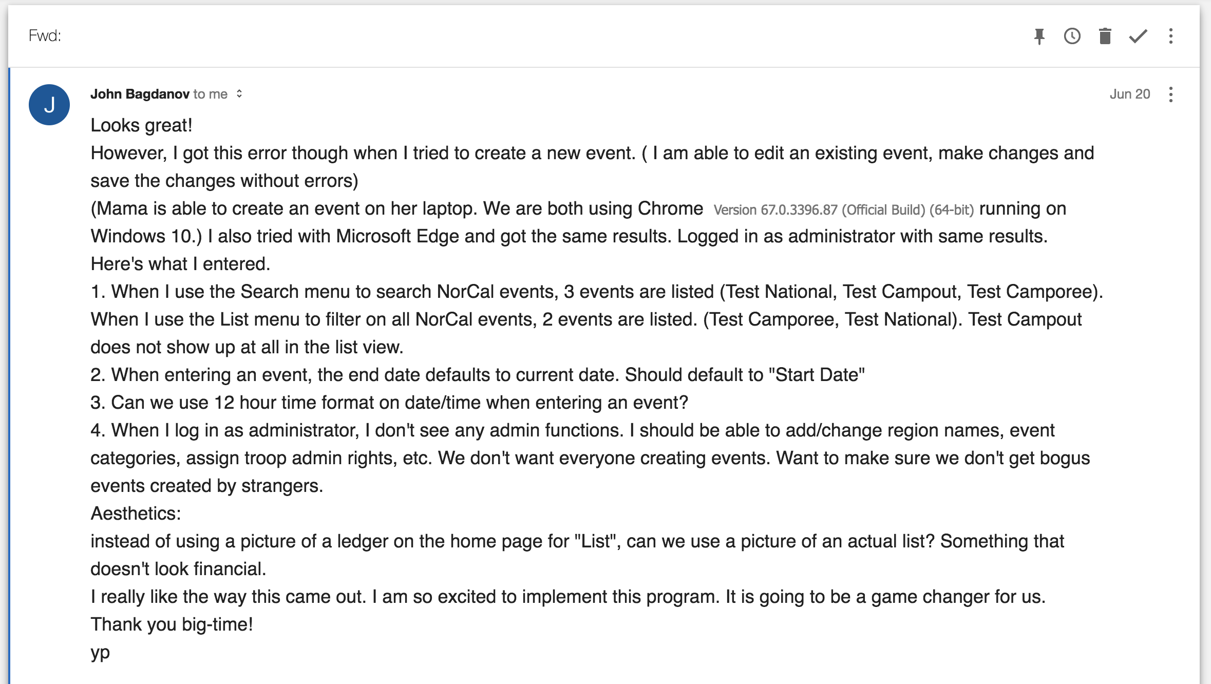

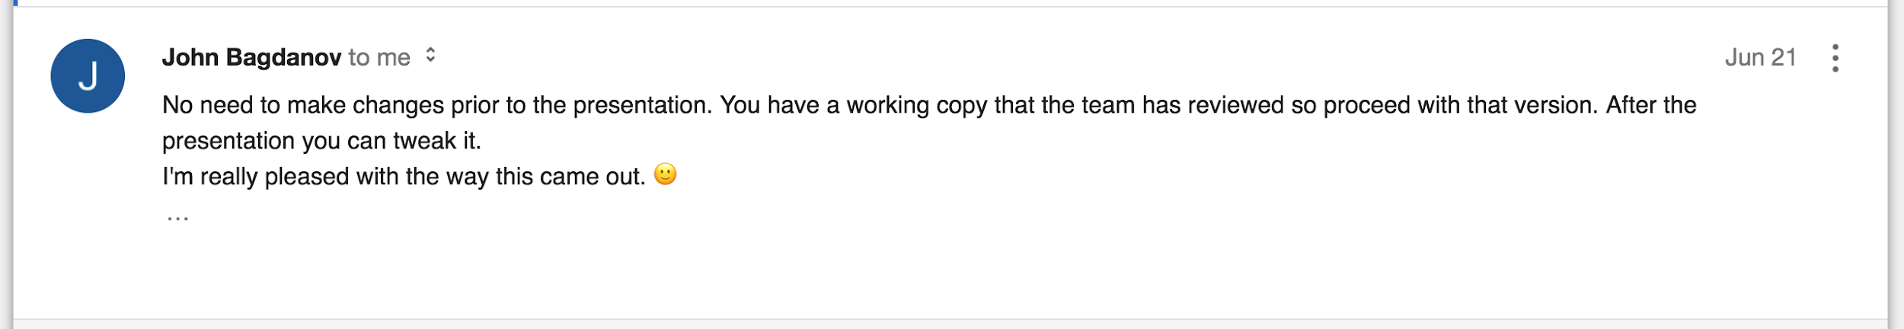

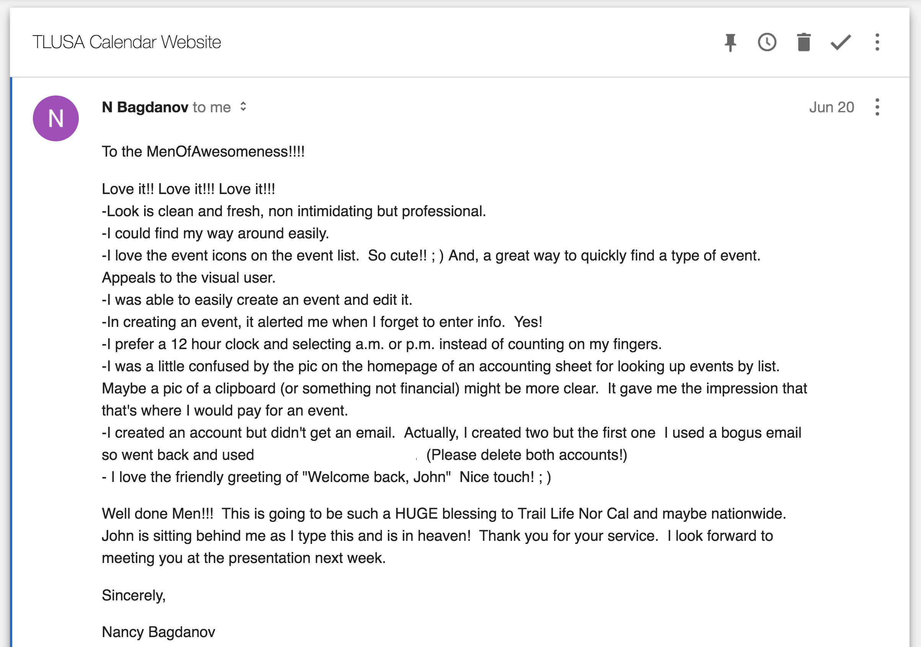

## Project Exit Questionnaire

Client Name: John Bagdanov

Organization: Trail Life USA

Email: j*****7@gmail.com

### Quality of Project

Q: Overall, how would you rate the quality of work done on your project? Functionality, design, etc.

Comments: *Excellent! This end product is user friendly; very easy to use. It has enhanced features such as Google maps which allow users to see where events will be held and allows them to generate directions straight from the application. It has multiple views and search capabilities which increases the simplicity for end users.*

### Scheduling

Q: How satisfied were you with the amount of time it took us to complete your project? How organized was the project?

Comments: *Formal project communication was light. Once the requirements were documented, there was minimal communication from the team. I was a little concerned that there weren’t any checkpoints during the build process to ensure what was being built truly aligned with what I requested. I was preparing myself to be disappointed since I had no way to validate the product before the end result was completed. But the team team delivered exactly what I asked, and even more than I expected. The team communicated the timeframe for when the work would be done and they delivered the end product a week early.*

### Responsiveness

Q: How satisfied were you with the quality and speed of our correspondence with you?

Comments: *Replies to my emails were very quick and very thorough. I believe I was the one who was slow to respond, yet the team kept to their scheduled and delivered a home run.*

### Future Projects

Q: If you required future web design work to be done, would you consider using us again?

Comments: *Absolutely. I have another project which I would love to get on the schedule :-)*

### Overall

Q: Could you please add some additional comments about the work we did for you:

Comments: *Coming from a design background myself, I took the time necessary to thoroughly document the requirements. The team replied to me with their understanding of my requirements and requested confirmation that they understood the requirements. Once I confirmed the requirement, they proceeded to designing and code the product. What didn’t happen, and I wish it did, was to meet with the team and have them make suggestions that would have refined and improved my vision for the product. Similar to an initial consultation with a potential client. That didn’t happen but in the real world, should happen. Also, in the real world there would be client checkpoints to review progress with the client as the solution is being developed, That also didn’t happen.*

*If I consider what I asked for and what I got, I am extremely pleased. The team delivered exactly what I wanted. They also went above and beyond by anticipating ways to improve the end user experience and incorporating those improvements into the end product. I am extremely pleased with the work they produced.*

*Great job team!!!*

*Thank you!*

# Lessons Learned

## Opportunities For Improvement

The major issue was a lack of knowledge in respect to the Django platform. It was introduced to the team earlier in the year but had only received five weeks of instruction. The majority of the app’s development utilized concepts that were not taught and had to be learned on our own. Other areas that needed improvement were in time management. When working in software development, it is very difficult to estimate how long a task will take. Unexpected errors can arise that consume hours on debugging. When working on the application, it is better to work on a single item and make sure it works and then commit before moving on to another part of the application.

## Team Issues & Resolution

The team had no major issues in this particular project, but experienced minor problems such as not understanding each others’ roles. The team can improve the face to face meetings to increase the productivity of the project. When solving a problem such as debugging code, face to face interactions were the best form of communication.

# Appendix A

## Gantt Chart

# Appendix B

## Entity Relationship Diagram

# Appendix C

## Data Dictionary

# 

# Appendix D

## Data Flow Diagram

# Appendix E

## Network Diagram

# Appendix F

## Test Plan

**Seth Bagdanov**

**Hugo Morales**

**Eric De La Cruz**

CIS-490-IBT01 Computer Information Systems Project

Fresno Pacific University

### Online Adventure Finder Test Plan

**Version:** 1.1

**Created:** 6/14/2018

**Last Updated:** 06/26/2018

**Status:** FINAL

**Revision and Sign-off Sheet**

Document History

| **Version** | **Date** | **Author** | **Description of Change** |
| --- | --- | --- | --- |
| 1.0 | 06/14/2018 | Eric De La Cruz | Draft |
| 1.0 | 06/18/2018 | Hugo Morales | Draft - Reviewed |
| 1.1 | 06/25/2018 | Seth Bagdanov | Draft - Revised with bug patches |
| 1.2 | 06/26/2018 | Seth Bagdanov | Finalized |

Approvers List

| **Name** | **Role** | **Approver** | **Approval Date** |
| --- | --- | --- | --- |
| Seth Bagdanov | Project Manager | SB | 6/14/2018 |
| Hugo Morales | Project Team | HM | 6/18/2018 |
| Eric De La Cruz | Project Team | ED | 6/25/2018 |

Reference Documents

| **Version** | **Date** | **Document Name** |
| --- | --- | --- |
| 1.0 | 06/14/2018 | SeniorProject_V01 - Online Adventure Finder |

#### INTRODUCTION

##### Purpose

This test plan describes the testing approach and overall framework that will drive the testing of the “SeniorProject_V01 – Online Adventure Finder” project, henceforth also referred to as “OAF”.

Test Strategy: rules the test will be based on, including the parameters of the project (e.g.: objectives, assumptions, principles, data); description of the process to set up a valid test.

Execution Strategy: describes how the test will be performed and process to identify and report defects, and to fix and implement resolutions to the issues found.

Test Management: process to handle the logistics of the test and all the events that come up during execution (e.g.: communications, escalation procedures, risk and mitigation, and team roster)

##### Project Overview

Calendar page will display all events for a given month in a standard calendar tabular form. Event details will be tested when a user clicks on the specific event. The login and logout functions will be tested to make sure that unregistered users cannot access content if they are not logged in. All URLs on the site will be tested to ensure they are properly formed. Create and edit pages will be tested for input validation and proper handling of data.

##### Audience

Project team members perform tasks specified in this document and provide input and recommendations as necessary.

Project Manager plans for the testing activities in the overall project schedule, reviews the document, tracks the performance of the test according to the tasks specified herein, approves the document, and is accountable for the results

Technical Team ensures that the test plan and deliverables are in line with the design, provides the environment for testing and follows the procedures related to the fixes of defects

#### TEST STRATEGY

##### Test Objective

The objective of the test is to verify that the functionality of the “SeniorProject_V01 – Online Adventure Finder” project according to the specifications. The tests will execute and verify the system programming. High and medium severity defects will be identified, fixed and retested per the specified criteria, and lower severity defects will be prioritized for future fixing. Testing will be broken down into a number of sections, with each section addressing a different component of the site.

The final product of the test is:

* Production-ready software;
* Set of stable test scripts that can be reused for functional and test execution.

##### Test Principles

There will be common, consistent procedures for all teams supporting testing activities. Testing processes will be well defined with the ability to change as needed per a documented change procedure. They will build upon previous stages to avoid redundancy or duplication of effort. Testing will be a repeatable, quantifiable, and measurable activity. Testing will be divided into phases, each with clearly defined objectives and goals.

##### Data Approach

In functional testing, “SeniorProject_V01 – Online Adventure Finder: will contain pre-loaded test data and which is used for testing activities. Test results will assume valid data loaded into the database for initial testing.

##### User Acceptance Test (UAT)

This test focuses on validating the system logic. It allows the end users to complete one final review of the system prior to deployment. The UAT is performed by Hugo and Eric.

To perform the test, the OAF users will input data and the system will generate outputs based on system policies. The end users will be tested in the roles created including user, troop, and district personnel. Project team members will enter input data using these scenarios to test cases based on real life data that would be used in a production system. After testing is completed the product will be released to Trail Life USA.

| **No.** | **Deliverable Name** | **Author** | **Reviewer** | **Result – date or description of error** |
| --- | --- | --- | --- | --- |
| 1 | Navigation | Seth Bagdanov | Hugo Morales | Passed - 6/14/2018 |
| 2 | Events | Seth Bagdanov | Hugo Morales | Passed – 6/14/2018 |
| 3 | Calendar | Seth Bagdanov | Hugo Morales | Passed – 6/14/2018 |
| 4 | Search | Seth Bagdanov | Hugo Morales | Passed – 6/14/2018 |
| 5 | List | Seth Bagdanov | Hugo Morales | Passed – 6/14/2018 |
| 6 | Event Detail | Seth Bagdanov | Hugo Morales | Passed – 6/14/2018 |
| 7 | Permissions | Seth Bagdanov | Hugo Morales | Passed – 6/25/2018 |
| 7.1 | User creation defaults to User=0 or User=1 equivalent levels | Seth Bagdanov | Hugo Morales | Default user level will error when accessing event details |
| *7.2* | *Create/Edit pages are only accessible to admin users and throws permission denied error when accessed by subordinate user levels* | *Seth Bagdanov* | *Hugo Morales* | *Bug: Normal user can access Edit events.*  *If I copy and paste* [*http://127.0.0.1:8000/event/edit26/*](http://127.0.0.1:8000/event/edit26/) *it lets me edit the event.* |
| 7.2 | Create/Edit pages are only accessible to admin users and throws permission denied error when accessed by subordinate user levels | Seth Bagdanov | Seth Bagdanov | Passed – 6/25/2018 |
| *7.3* | *Entire site requires user login to view and throws login required alert with link to login/register* | *Seth Bagdanov* | *Hugo Morales* | *Bug: I can access* [*http://127.0.0.1:8000/event/edit26/*](http://127.0.0.1:8000/event/edit26/) *when not logged in.* |
| 7.3 | Entire site requires user login to view and throws login required alert with link to login/register | Seth Bagdanov | Seth Bagdanov | Passed – 6/25/2018 |
| 7.4 | >=District Admins may create/edit events in any district | Seth Bagdanov | Hugo Morales | Passed – 6/14/2018 |
| 7.5 | Troop Admins may only create events in own district and that district only. | Seth Bagdanov | Hugo Morales | Passed – 6/14/2018 |

## 

##### Test Conditions

| **#** | **Category** | **Title** | **Conditions** |
| --- | --- | --- | --- |
| 1 | Navigation |  |  |
| 1.1 | Navigation | Navbar Functional | Each link in the navbar will be tested for directing to the respective page. Drop-down menus will display contents upon click or hover. Branding will link to home page. |
| 1.2 | Navigation | URLs Correct | All URLs will direct to their stated target. No link will direct to a page that does not match the description of link. No broken links. |
| 1.3 | Navigation | Error URL Handling | Incorrectly specified URLs entered manually will raise an appropriate error page without sharing server technical information. |
| 2 | Events |  |  |
| 2.1 | Events | Event Creation | Completing the “Create Event” page and clicking Submit will successfully create an event with the entered data. The event will display on all three views (List, Calendar, Search) when appropriate criteria is specified for inclusion. |
| 2.2 | Events | Event Editing | Opening the Edit page on an event will populate the form with the event details for editing. Clicking Submit will save the data entered to the Event instance. |
| 2.3 | Events | Event Form Handling | The Create and Edit forms will validate data entered and display appropriate error messages and helper text or tooltips. Data will be processed and saved to the correct variables within the Event instance. |
| 3 | Calendar |  |  |
| 3.1 | Calendar | Event Day Cell Display | The Calendar view will show all events in their respective day(s) |
| 3.2 | Calendar | Day Cell Readability | Events in the Calendar page will be identifiable as an event versus a blank cell. Multiple events per day will not overlap one another. |
| 3.3 | Calendar | Navigation Check | Clicking the event name will load the event detail page.  Clicking the navigation buttons will load the previous/next month with their respective events. |
| 4 | Search |  |  |
| 4.1 | Search | Search Form Handling | Search form will validate data when entered |
| 4.2 | Search | Submit and Reset Check | Submit button will update the Search Calendar view with events matching the condition(s) specified.  Reset button will clear the search form and return the calendar to display all events for the current month. |
| 4.3 | Search | Results Display | Results will display on their correct days. Only events matching the criteria will display. Links will function to each event detail. |
| 5 | List |  |  |
| 5.1 | List | Event List Display | Events are listed in ascending order after the present date. Events will show their matching category icon that corresponds to the event category. Data displayed for each event will be from that event instance. |
| 5.2 | List | Filter Options Check | District and Category filtering options will only show events matching one or both of the criteria. |
| 5.3 | List | Search and Reset Check | Search button will update the view with events matching the condition(s) specified.  Reset button will clear the condition(s) and display all upcoming events. |
| 6 | Event Detail |  |  |
| 6.1 | Event Detail | Data Display Check | Correct event details are displayed. |
| 6.2 | Event Detail | Data Formatting | Data is formatted properly depending on the type of data. Dates will be readable. Times will be in standard format. URLs will be active. |
| 6.3 | Event Detail | Icons Check | Icons for the date, time, district, category, contact type, and directions will display the proper icons. |
| 6.4 | Event Detail | URL Validation | URLs will display the proper targets when clicked. The Google Maps URL will build properly and display directions to the Event’s address when clicked. |
| 6.5 | Event Detail | Map Display | A functioning embedded Google Map will show at the bottom of the page and support live user interaction. |
| 7 | Permissions |  |  |
| 7.1 | Permissions | EventDetail Edit Icon | The “Edit” icon will show beside the event title on the Event Detail page when the page is accessed by either a district admin or the creation user. |
| 7.2 | Permissions | Navbar Create Icon | A link to the “Create” page will display on the navbar when a user logs in with permissions >= TroopAdmin |
| 7.3 | Permissions | User Creation Default | User accounts will default to user level permissions when created |
| 7.4 | Permissions | Create or Edit Permission Check | Site will check user permissions when accessing the “Create” or “Edit” pages. A permissions error will display if a user attempts to access these pages directly. |
| 7.5 | Permissions | Site Login Check | Any user attempting to access the site must be logged in to view content. |
| 7.6 | Permissions | DistrictAdmin Check | DistrictAdmin users will have the option to select any district from the district dropdown on the Create or Edit pages. |
| 7.7 | Permissions | TroopAdmin District Check | TroopAdmin users will have a single option on the district dropdown on the Create or Edit pages. The option will be the district they are a member of. |

#### EXECUTION STRATEGY

##### Entry and Exit Criteria

The entry criteria refer to the desirable conditions in order to start test execution; only the migration of the code and fixes need to be assessed at the end of each cycle. Entry criteria to start the execution phase of the test: the activities listed in the Test Planning section of the schedule are 100% completed.

The exit criteria are the desirable conditions that need to be met in order proceed with the implementation. Exit criteria for each cycle: the activities listed in the Test Execution section of the schedule are 100% completed at each cycle.

Entry and exit criteria are flexible benchmarks. If they are not met, the test team will assess the risk, identify mitigation actions and provide a recommendation. All this is input to the project manager for a final “go/no-go” decision.

| **Exit Criteria** | **Project**  **Lead** | **Project**  **Team** | **Notes** |
| --- | --- | --- | --- |
| 100% tests executed | SB | SB | All tests passed. – 6/28/2018 SB |
| 95% pass rate of tests | SB | SB | 6/28/2018 SB |
| No open Critical and High severity defects | SB | SB | All critical, high, and moderate bugs resolved. – 6/28/2018 SB |
| All remaining defects are either cancelled or documented as Change Requests for a future release. | SB | HM  ED | A couple bugs remain in the category of “Permissions”. – 6/18/2018 HM |
| All expected and actual results are captured and documented. | SB | HM  ED | Bug list updated – 6/13/2018 HM |
| Test environment cleanup completed and a new back up of the environment. | SB | HM  ED | Last backup – 6/13/2018 ED |

##### Test Cycles

There will be two cycles for functional testing. Each cycle will execute all the scripts. The objective of the first cycle is to identify any blocking, critical defects, and most of the high defects. It is expected to use some work-around in order to get to all the scripts. The objective of the second cycle is to identify remaining high and medium defects, remove the work-around from the first cycle, correct gaps in the scripts and obtain performance results. UAT test will consist of one cycle.

##### Validation and Defect Management

Testers will utilize the test cycles to execute all scripts in each of the cycles. Project team can do additional testing if they identify any errors or gaps in the scripts when editing and running the project through either Visual Studio or GitHub. If an error is identified the script will be updated and a defect error can be logged.

Defects will be tracked through Google docs on a shared drive. The project team will gather information on a daily basis and request additional details from project lead. The project team will work on fixes. It is the responsibility of the tester to identify the defect and link them to the corresponding script and update the testing log. Project lead can input defect details for communication with project team in order of severity of defect taking precedence. Development team will review defect, ask for details if necessary, fix the defect, and communicate to project lead when the defect is patched.

#### TEST MANAGEMENT PROCESS

##### Test Design Process

The tester will understand each test requirement and prepare corresponding test case to ensure all requirements have been met. Each test case will undergo review by the project lead and the reviewed defects are captured and shared to the project team. Testers will maintain testing log in Google shared drive testing log document. The testing log can lead to change requests within the scope requirements. Any subsequent changes to the test case will be communicated directly to the shared drive and project team.

##### Test Execution Process

Project lead will approve test cases and push updated test environment to GitHub for testing, tester will start testing to ensure the application is stable for testing. Each tester is assigned test cases though the project lead. At any time when the tester encounters a critical error or delay the issue will be elevated to the project lead immediately. Each tester performs a step by step execution and updates the testing log on the Google shared drive. The tester enters a pass or fail with the date for each step. Project team will coordinate to ensure all test cases are executed with either pass/fail. During the subsequent cycle all defects fixed will be tested and updated in the shared document.